Student Nurse
Supervision Standards – 2017

Contract Agreements: Gundersen Health System maintains a current contract with the school.

Student Preparation: Prior to the start of clinical the student nurse will complete:
Student Registration: Each student will complete the online student registration provided by Gundersen Health System each semester. This is a 2-step process:
  - First, students need to complete the online registration process, as described in the registration letter (provided by the school). After that is completed, the registration will be approved by Gundersen and an automated email letter will be sent to the student. Allow 2-3 weeks for this to occur. Please look for this letter, as it will provide directions and passwords that will be needed to complete mandatory education.
  - Second, complete the Online Mandatory Education: Each student will complete on-line Mandatory Education once each calendar year.
EPIC Training: Complete online EPIC training, as a one-time requirement and review as needed.
  - Validation of Skills: Prior to the start of clinical, the school/student will validate student skills and readiness to complete skills in acute care.

On the Unit
Student Assignments: Faculty/preceptors will post student assignments the evening prior to clinical experiences. The student nurse intern is co-assigned with a staff RN on the team. This should not be counted into staffing and should not affect staffing patterns/assignment ratios.

Student Basic Functions: Students will provide safe, basic patient care for patients and families under the direct supervision of a staff RN/faculty in the hospital/clinic setting.
- Direct supervision means that the staff RN/faculty; coordinates, directs, and inspects cares provided by the student and
- An RN (staff RN or nursing faculty) will be present at the point of care for all medication administration and IV pump or PCA adjustments.

Student Goals and Objectives: It is expected that the student will share with the assigned RN, their
goals/objectives for clinical that day.

Unit Orientation: The faculty/preceptor will provide a basic orientation to the department to which the student is assigned prior to patient care.

EPIC Documentation: The student has basic EPIC/computer access and is able to document
interventions and cares performed. It is the RN’s (or faculty RN’s) responsibility to oversee and verify documentation entries before the student leaves the shift. Documentation is completed in the clinical note activity in EPIC. The RN must verify student documentation for accuracy (see screen shots in last section).
Remember: All student entries (e.g. vital signs, assessments, medication administration, and notes, etc.) must be co-signed using the smart phrase .student (see screen shots in last section).

- Assessment: May contribute to assessment by collecting and documenting data, however the RN must assess and document on each patient as per the Nursing Assessment, Reassessment, Adult and Pediatric Standard Operating Procedure-Hospital (GL-6730) and per practice standards (Example, the student nurse may listen to lung sounds and document within the Respiratory WDL, however the RN must complete and document their own assessment).

- Patient Education: It is the responsibility of the RN to initiate patient education and evaluate the patient’s response to the education. The student may complete the first page of the Learning Assessment only and can reinforce patient education that has been initiated by the RN.

- Patient Transfers: It is the responsibility of the RN to make the phone call to the receiving area and provide a comprehensive report using Situation, Background, Assessment, and Recommendation (S.B.A.R.) format.
Delegation:
Activities that MAY be delegated (under direct supervision of RN):
- It is an expectation that all care providers will follow the standards of care for hand hygiene, use of personal protective equipment, fall prevention, and the use of correct body mechanics in patient care provision.
- Administer all prescribed medications (based on department specific guidelines) under direct supervision of RN/faculty. The student nurse will be signing into the patient’s MAR with RN/faculty co-signing.
- Perform procedures with IV’s under direct supervision of RN/faculty and within unit guidelines
- Perform procedures that are invasive, requiring sterility or specimen collection under direct supervision of RN/faculty and within unit guidelines
- Demonstrate effective communication with health care team and patients/families

Activities that MAY NOT be delegated:
- Functions of assessment
- Create and revise the plan of care
- Initiate patient education and evaluate learning
- Receive or enter orders
- Administer chemotherapy
- Independently adjust IV infusion devices

Questions or concerns, please contact the Department of Nursing at ext. 57341.

EPIC DOCUMENTATION

Use these steps to document in a note that a student’s charting has been reviewed.

INPATIENT

1. Click on Notes and select New Note
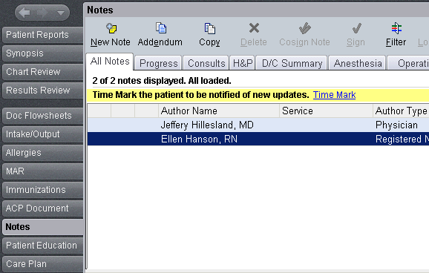

2. Note type; select Progress Notes, type smart phrase .student in the note section.
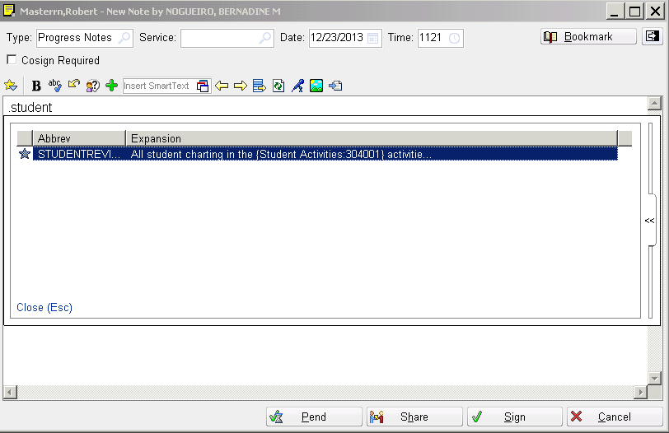

3. Press F2 for the drop down activities. Select activities from the smart list that the student charted to, i.e.: flow sheet and/or notes. Sign the note.
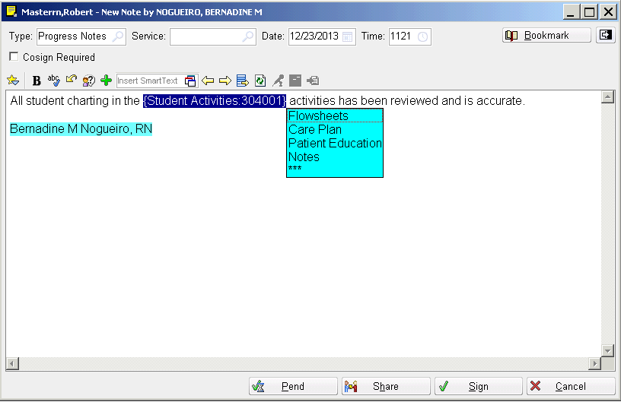

OUT-PATIENT

1. Under Visit Navigator click on Clinical Support note. In the box type the smart phrase .student, highlight “STUDENTREVIEW” and press ENTER

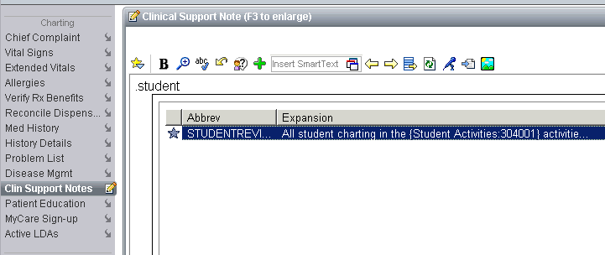

2. Press F2 for the drop down activities. Select activities from the smart list that the student charted to, i.e.: flow sheet and/or notes. Close encounter.

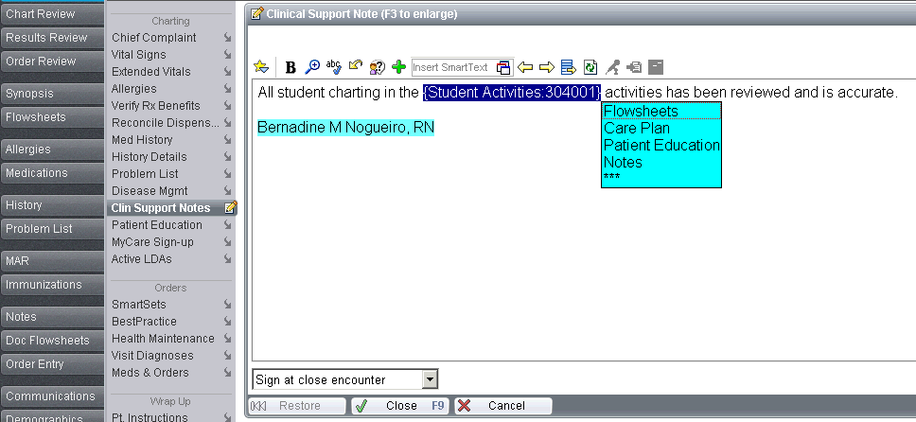

ED or Urgent Care

- In the ED Narrator, click on Notes in the Toolbox and then ED UC Note. In the text box type the smart phrase .student, highlight “STUDENTREVIEW” and press ENTER

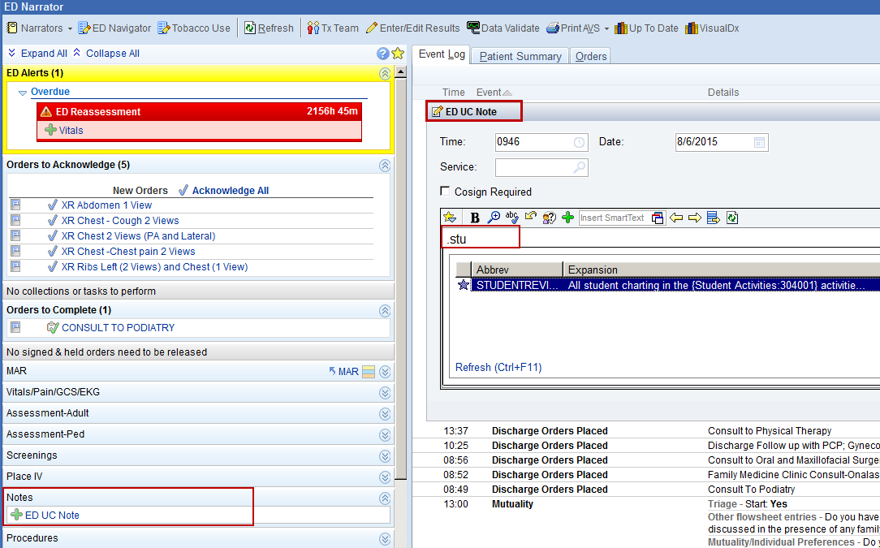

2. Press F2 for the drop down activities. Select activities from the smart list that the student charted to, i.e.: flow sheet and/or notes. Click Accept.

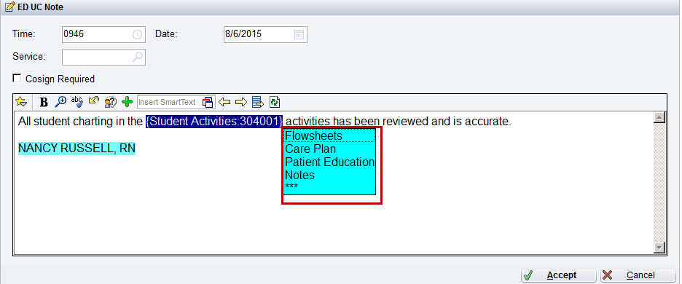

This material contains confidential and copyrighted information of Epic Systems Corporation.

