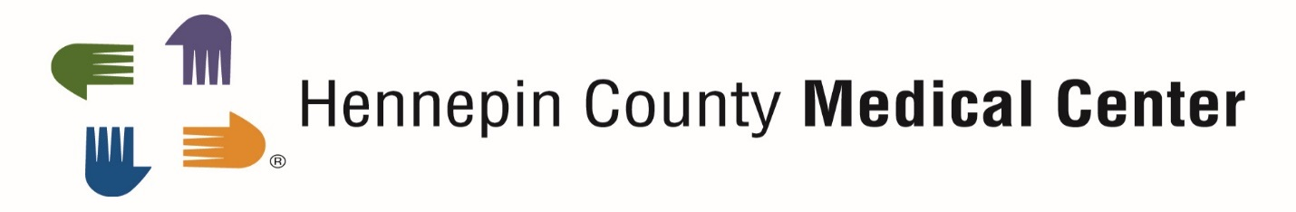

Completing Required Orientation Prior to Starting Your Clinical Experience at Hennepin County Medical Center
Prior to starting your clinical experience at Hennepin County Medical Center (HCMC), you are required to complete some on-line orientation. This orientation is required for both students and instructors. All of this orientation can be done remotely via My Learning Center. The orientation needs to be completed once every academic year from September-August. This orientation should take approximately 1 ½ - 2 hours to complete. You do not need to do all of the orientation at one time. You are able to go back to My Learning Center until you have completed the required orientation.
Internet Explorer is the recommended browser to complete the required orientation. Please contact the helpdesk at 612-873-7485 if you have any problems with accessing or completing the required orientation.

Signing in to MY LEARNING CENTER:
- Go to https://learn.hcmed.org
- Type your 11 - digit PeopleSoft number into the Username AND Password fields
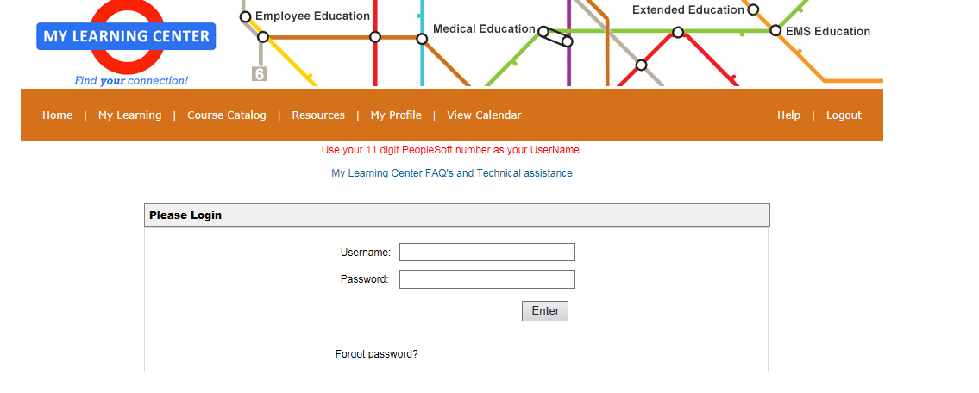
- Click the enter button
- You will be prompted at this time to create a new password.

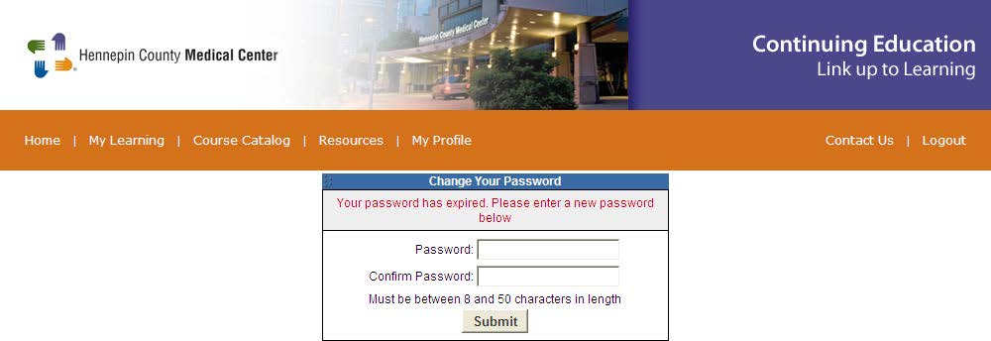
- Returning students/instructors to HCMC will need to use previously created password. If you do not remember the password, please answer security questions you established or contact the IT service desk at 612-873-7485 to have your password reset.
Registering for your required orientation:
Before you can begin your required orientation, you need to register for the appropriate training.
- From the My Learning Center home page, click on Course Catalog.

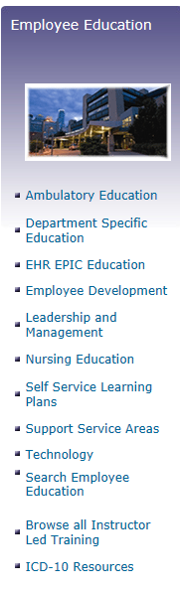
- Under the heading of Employee Education, click on Self Service Learning Plans.

- Register by clicking the green “plus” button to the right of your required orientation - 2017-2018 Orientation to HCMC for Nursing Student and Clinical Instructor. Only add this training to your To Do list. Please do not add any other training to your to do list, even if it indicates required. The only required orientation for nursing students and instructors is the one highlighted above.

- All of your required orientation will now be in your To-Do List.

Viewing and completing your required orientation:
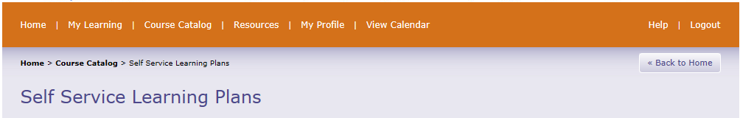
- Click My Learning on the top navigation bar

- Click “My-To-Do List”
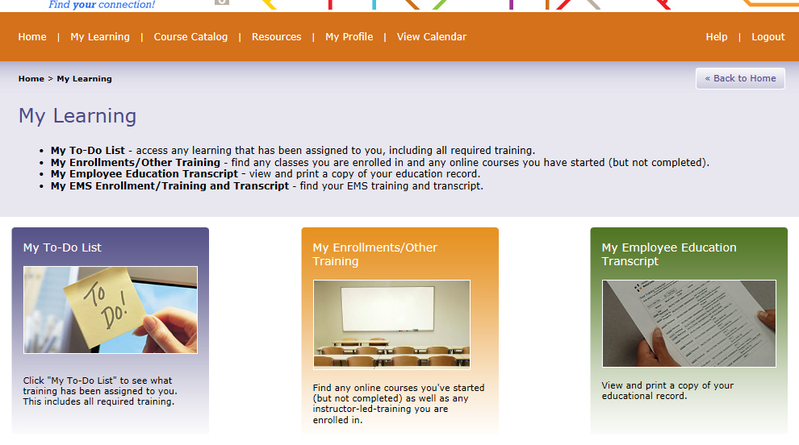

- You should then see the 2017-2018 Orientation to HCMC for Nursing Student and Clinical Instructor (Required) training on your To Do list.

- Click the name of the course in your To Do list - 2017-2018 Orientation to HCMC for Nursing Students and Clinical Instructor (Required) – to open it.

- You will see 10 courses. Please complete all of them by either clicking the name of the course or the quick launch link on the right hand side to start the course.

Printing or emailing certificate of completion of orientation:
- When you have completed all of your courses, your To Do list will move to the complete section. This is where you will find your certificate of completion. Click the Complete section of your To Do list, then click the blue and white drop down next to where it says 100% complete.
- Chose view certificate.
- Print or save certificate.
- Submit proof of completion to your school contact or instructor.
- Required orientation needs to be completed at least 5 business days prior to the start of your clinical rotation at HCMC.

Students/Instructors may not be at a clinical site until they have completed the online orientation. Please complete the orientation at least five business days before the start date of your clinical experience. Without this time allowance, we cannot ensure that you will be able to complete your rotation at HCMC.

