Because of a vendor contract change, all Pyxis scrub dispensing and return stations at Gundersen Health System have been replaced with stations from a new vendor. A new scrub color –jade green – has also been added to help Gundersen meet regulatory compliance for those who work in an unrestricted area

**Ceil Blue scrubs** are to be worn it you are working in a restricted or semi-restricted area. You must also wear a Ceil Blue cover jacket, hair bonnet and if also beard cover if needed.

**Jade green scrubs** are to be worn if you are going to be working in an unrestricted area.

Warm-up or cover jackets of both colors will be in the common area also but will be located on separate shelving.

Students will now report to the common area near Elevators F to get scrubs for their rotation (See attached map for the common location). Upon completion of their rotation they will need to go to the 5th floor in the GI area or Lower Level in Central Services to return their scrubs in the return pyxis machine.

* **Directions to GI Area return pyxis machine**: Take elevator E to the 5th floor. Take a right off the elevator and head towards peds subspecialties. Walk past POD B and the return pyxis machine will be located on the right side across from the staff lounge and next to the men’s restroom.
* **Directions to Central Service return pyxis machine**: Take the employee side of elevator F down to the lower level. Take a right immediately off the elevator and take another right after that which you will go past two exit signs. Follow the hallway to the other side of elevator F and the return machine with be straight ahead. The return machine will be the one on the right.
* Warm-up or cover jackets can be returned to a dirty laundry bin

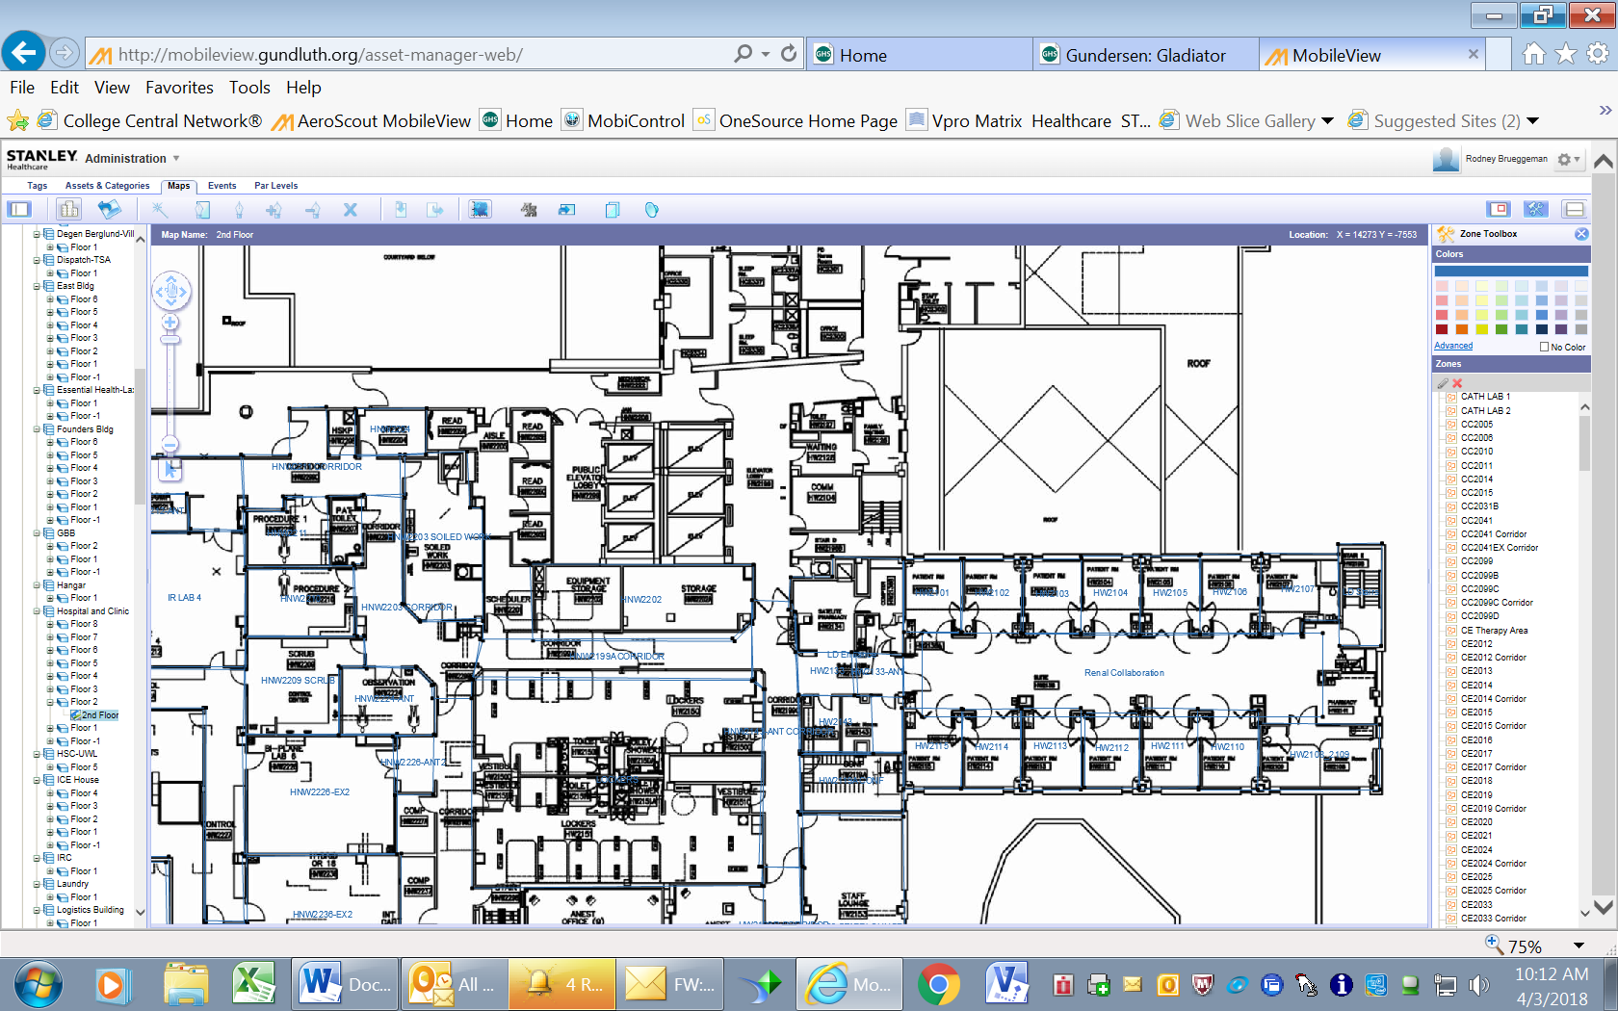

**Elevator F**

2nd Floor Common area for new scrub vending

If you have any issues with getting scrubs out of the new machines or returning them, please feel free to contact Chelsey Dehning for Undergrad and Graduate Allied Health Students at ext 56749 or Mai Vue for Undergrad and Graduate Nursing Students at ext 55953 or Billy Banes Senior Office Assistant ext 56743 with any questions as well.

Please review the following if you wear scrub attire provided by Gundersen Health System:

* On 2nd floor, scrub dispensing units will be placed in a common area. (See attached map for the common location)
* 2nd floor common area will have 3 large dispensing units for ceil blue scrubs and 1 large dispensing unit for jade green scrubs.
* Warm-up or cover jackets of both colors will be in the common area also but will be located on separate shelving.
* With students not having access to the OR locker rooms they will have to return their scrubs in the GI area on 5th floor of the heritage building or in Central Service in the Lower Level of the heritage building.
* If students are working in a restricted or semi-restricted area they will be required to wear ceil blue scrubs.  They must also wear a ceil blue cover jacket, hair bonnet and if also beard cover if needed.
* Jade green scrubs are to be worn if students are going to be working in an unrestricted area.

Scrub stations located in the 2nd floor common area will be loaded with the following scrub colors for each area:

* + **GI – Jade green**
  + **Emergency Services – Jade green**
  + **L&D**-ceil blue (misty green jacket)
  + **NICU/PICU**-misty green (if on a L&D rotation following baby to the NICU they can keep the L&D ceil blue-misty green jacket on, no need to change).
  + **OB/Nursery**-Can wear their school uniform
  + **Peds** - Can wear their school uniform
  + **Maternal/Peds NICU – Ceil Blue**
  + **5th floor OSC – Ceil Blue**
  + **Central Service – Ceil Blue**
  + **Integrated Platform – Ceil Blue** 
    - **Heart Cath Lab / Cath Lab**
    - **Pre Op**
    - **Post Op**
    - **OR**
    - **Interventional Radiology**

How to **GET** Scrubs

1. Slide your student badge through the reader with the bar code facing up on the Scrub Pyxis machine with the color of scrubs you are needing for the rotation.

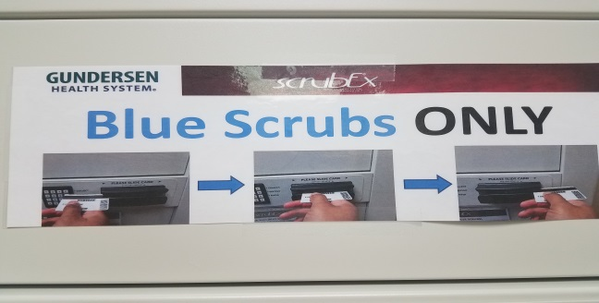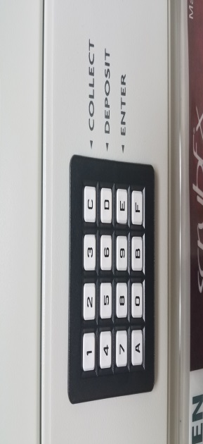

1. Press the “C” button on the key pad to collect the scrubs
   1. Do not select “F” at anytime

1. After looking at the size chart, type in the number on the key pad. The number can be found by the size of scrubs you ae wanting to select on the chart

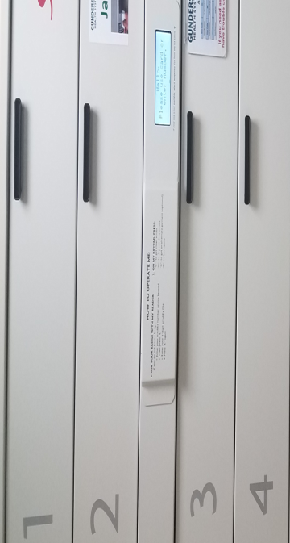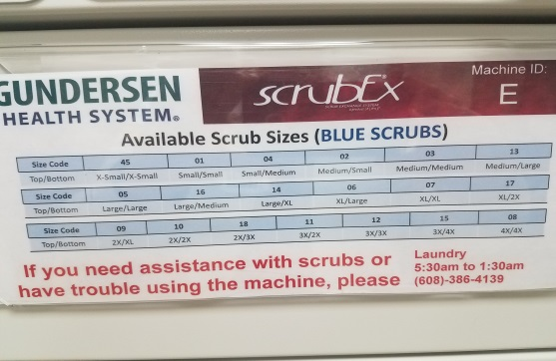

1. The drawer number to open will appear on the screen, open the drawer and take the scrubs out. ** The door is spring loaded so please make sure you hold the door down while taking out the scrubs.

How to **RETURN** Scrubs

1. Slide your student badge through the reader with the bar code facing up

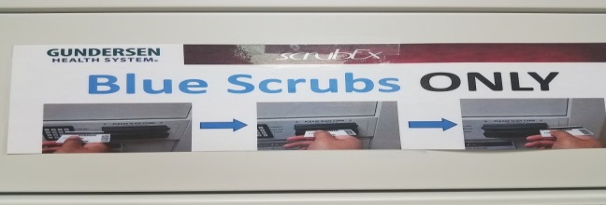

1. Pull bin open ~ separate the bottom and top scrubs, put the top in the top section and the bottoms in the bottom section in the drawer.

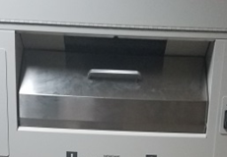

1. Close the bin door
2. Make sure the garments have been added back to your student badge

**Scrubs Pyxis Machine to return Scrubs**

**Scrubs Pyxis Machine to get Scrubs**

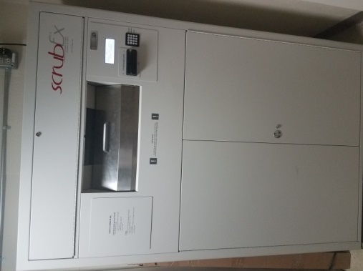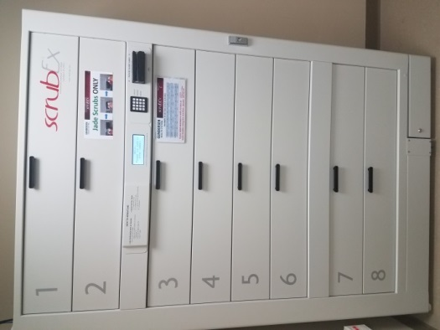

Just a friendly reminder, blue scrubs are not to be worn outside, period. Monitoring of this will now occur with the new machines in place for compliance. The Jade Green scrubs can be worn outside but cannot be worn off the Gundersen Health System campus. Please keep in mind; this is an organizational change and we are being asked to comply with the changes

Due to the changes occurring we asking for your patience and to make sure you and your students are allowing enough time to get scrubs prior to reporting to the department for the rotation.

Please let me know if you have any questions.

Thank you,

Chelsey Dehning, Medical Education Specialist ~ Graduate and Undergrad Allied Health Students

Mai Vue, Medical Education Specialist ~ Graduate and Undergrad Nursing Students

Billy Banes ~ Senior Office Assistant