Collecting and Returning Clean Attire
*If you have any issues with collecting or returning scrubs, contact ext. 56749 or ext. 56741

Collecting Clean Attire
Note:
- Ceil blue scrubs are worn in the restricted or semi-restricted area (e.g. Surgery, Cath Lab, IR). You must also wear a ceil blue scrub jacket, hair bonnet, shoe covers, and beard cover (if applicable). Ceil Blue scrubs may not to be worn outside
- Jade scrubs are worn in the unrestricted area (e.g. Pre-Op, PACU)
- Scrub jackets are available in the linen cart next to the scrub pyxis

Where: Locate the scrub pyxis machines near Elevators E on 2nd floor of the heritage building (location last known as the “old chapel;” see map below):
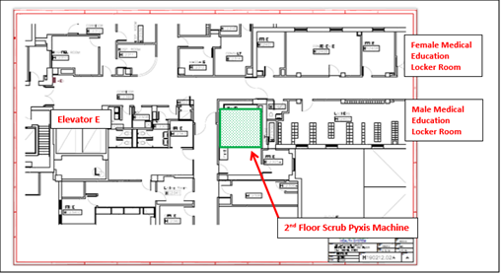

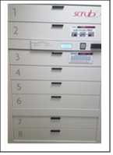

How:
- 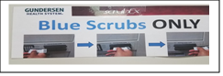Slide your student badge through the reader with the bar code facing up on the Scrub Pyxis machine (be sure you are accessing the correct colored scrubs for the area you are observing). Follow instructions posted on the machines
- 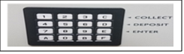Press the Collect “C” button on the key pad to collect the scrubs
- After looking at the size chart, type in the number on the key pad. The number can be found above the size of scrubs you ae wanting to select on the chart (located on the scrub machine)
- 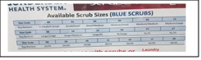The drawer number to open will appear on the screen, open the drawer and take out scrubs (door is spring loaded so be sure to hold the door down when getting scrubs out)

Returning Clean (“Dirty”) Attire
Note:
- Check the pockets of your scrubs before returning. If you forget something in the pocket of your scrubs after they have been returned, contact Medical Education (information above)
- Scrubs must be returned after every rotation

Where: Return the scrubs to the same location you retrieved your scrubs, or you can return in the following locations:
- GI Area: Take elevator E to the 5th floor. Take a right off the elevator and head towards peds subspecialties. Walk past POD B and the return pyxis machine will be located on the right side across from the staff lounge and next to the men’s restroom.
- Central Service: Take the employee side of elevator F down to the lower level. Take a right immediately off the elevator and take another right after that which you will go past two exit signs. Follow the hallway to the other side of elevator F and the return machine will be straight ahead. The return machine will be the one on the right.

*Warm-up or cover jackets can be returned to a dirty laundry bin
How:
- Slide your student badge through the reader with the bar code facing up (as done when collecting scrubs)
- Pull bin open and deposit scrubs as indicated
- 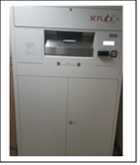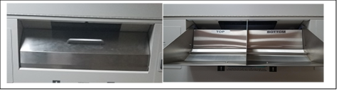
Close the door to receive credit

