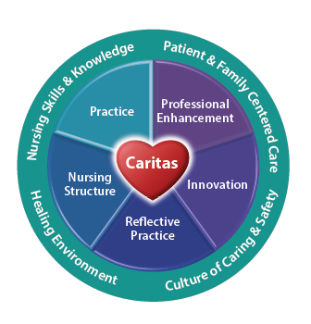
__(Department)_____Team,

Please welcome students and faculty to the unit!
We all play a critical role in providing a culture that offers an exceptional opportunity for learning and recruitment of future nurses at Gundersen Health System. __ (School of Nursing) __ students will soon be arriving on the unit for clinical experiences. You may see them around the unit for a tour on _ (clinical orientation day) ___ during their Orientation Day. Students will start on the floor with an assigned student preceptor on ___ (start date) __ with clinical completion on __ (end date) ___. ___ (number of students) ____will be on the unit on ___ (days/shifts of the week) ____. Each student will be assigned ____ (number of shifts) _____over the clinical course. Primary instructor(s) for this clinical group is/are _____(names)______.
The students coming are ____ (e.g., sophomore, junior, senior, DEU_____) and can perform all the same skills and tasks as our bedside RNs (if needed utilize except _____________). Charge RNs will be assigning each student a student preceptor. When there are not enough preceptors for each student, the charge nurse will assign students to the designated alternative area,_____ (designated alternative area) ___. It is important to familiarize yourself with the student resources, which will be in the Preceptor binder at the ___ (e.g., CN desk/nursing station) ____This includes the Student Supervision Standards, Undergraduate Nursing Alternative Clinical Experience Plan, faculty contact information, student course objectives/outcomes, and faculty/student expectations.
If you have any questions or concerns, reach out to a leadership team member.

Thank you for growing our future workforce,

____ (Leadership team member names) _______

