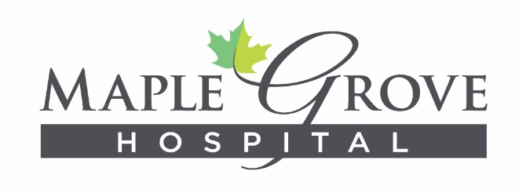

RECEIPT FOR REQUIRED LEARNING PACKET 2023-2024
Regarding information in the Required Learning Packet, I:
- Understand the information
- Am responsible for working safely, and
- Know who to contact to obtain more information or to report unsafe conditions

In addition, I understand that these policies and procedures are continually evaluated and may be amended, modified or terminated at any time.
Please sign and date this receipt and return it to Maple Grove Education Department or fax to 763-581-1405
Signature: Date:
Print Name:
S# : __________________________________________

School Name: __________________________________

